Log onto SCIS:
https://6507319.app.netsuite.com/c.6507319/pos/main.ssp?whence=&n=2#login
5hs
Search for: CS3081664
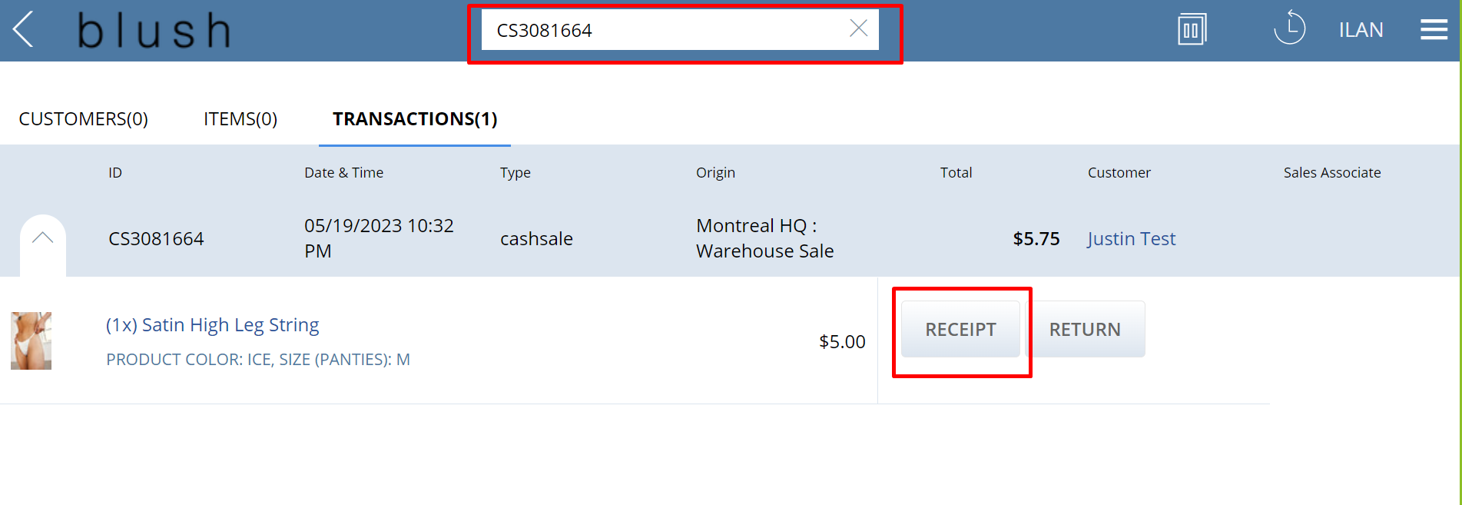Press on receipt, then switch it to CC receipt
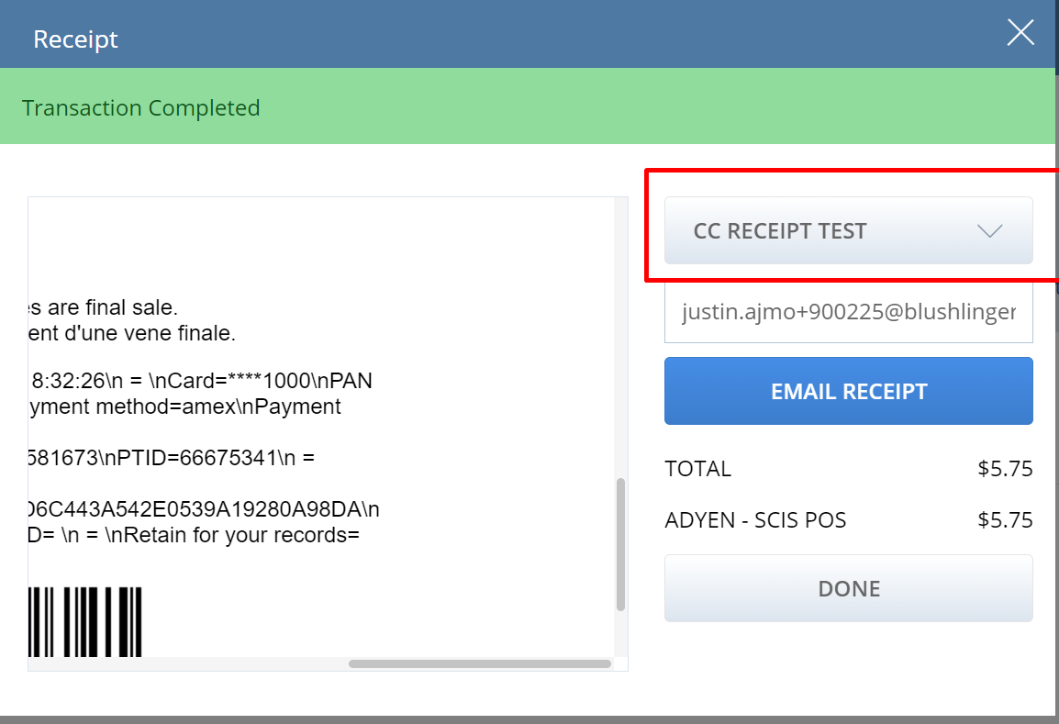
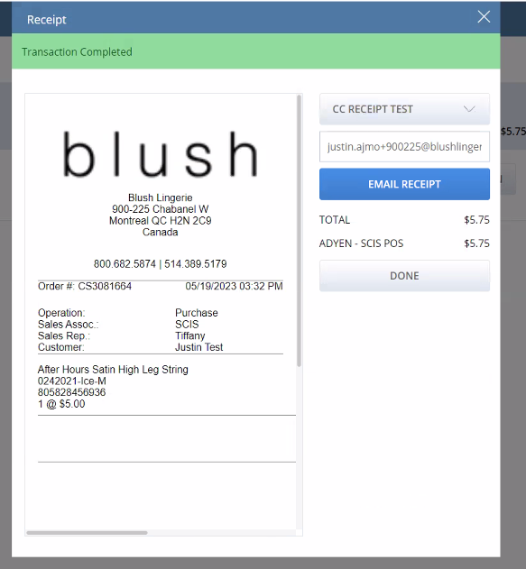
Customization -> Forms -> Advanced PDF templates: SCIS SuiteSuccess Receipt v2

On line 550:
<td>${payment.shopperprintblock?html}</td>
This has all the data
Card = **** 1000
Card type: Amex
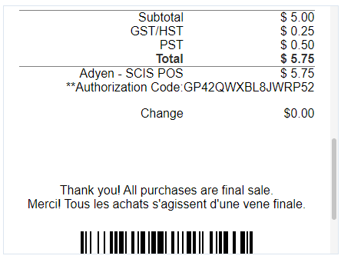
Uso documentacion:
https://freemarker.apache.org/docs/dgui_template_exp.html#dgui_template_exp_stringop
Ejemplo, uso substring para obtener “Card=****1000”:

<td>${payment.shopperprintblock?html?substring(73, 86)}</td>
Luego:
<#list payment.shopperprintblock?split("\\n") as item>
<#if item?starts_with("Card=*")>
<tr>
<td>${item}</td>
</tr>
</#if>

<#if item?starts_with("Card type=")>
<tr>
<td>${item}</td>
</tr>
</#if>
</#list>

Esto me da las dos, card y card type, luego tengo que separarlas.

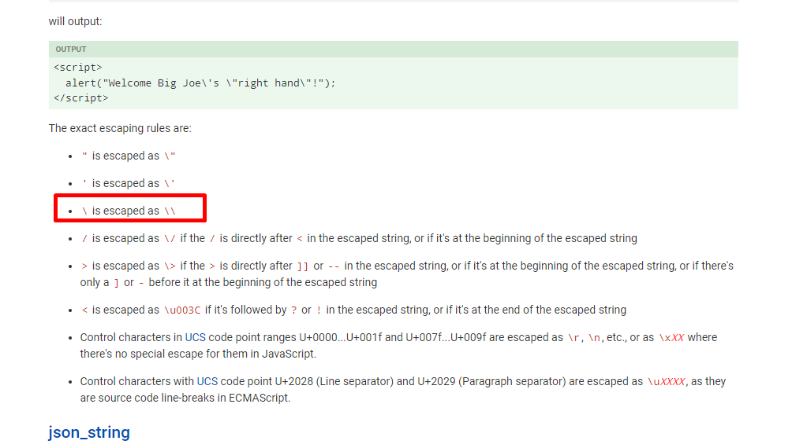
Lo mejoro y las separo, y además identifico cada parte que es:
<#if payment.shopperprintblock?has_content>
<#list payment.shopperprintblock?split("\\n") as item>
<#if item?starts_with("Card=*")>
<tr>
<td align="right" colspan="2">Card Number:</td>
<#list item?split("=") as card>
<#if card?starts_with("Card")?then(false,true)>
<td align="right">${card}</td>
</#if>
</#list>
</tr>
</#if>

<#if item?starts_with("Card type=")>
<tr>
<td align="right" colspan="2">Card Type:</td>
<#list item?split("=") as type>
<#if type?starts_with("Card type")?then(false,true)>
<td align="right">${type}</td>
</#if>
</#list>
</tr>
</#if>
</#list>

